Polynomial and Rational Graph Review:
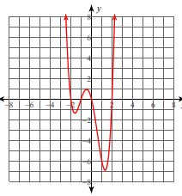
Write the equation of the polynomial using the following graph.

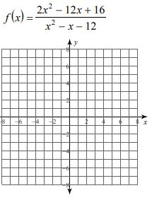
f(x) = ____________________________________________________________

Graph the following rational function.

Domain:
X-Intercepts:
Y-intercept:
Hole(s):
Vertical Asymptote:
Long Run Behavior:

